PROGRAMME REPORT
VIRTUAL BYST MENTORING PROGRAM
Entrepreneurship Development Program (EDP)
DATE  22–23 May 2024 | MODE  Virtual / Online
PARTICIPATION  40 members (as provided in the event details) | ORGANISER  Vignan Technology Business Incubator (Vignan TBI), in collaboration with Bharatiya Yuva Shakti Trust (BYST)

1. Introduction
Vignan Technology Business Incubator (Vignan TBI), in collaboration with Bharatiya Yuva Shakti Trust (BYST), conducted a Virtual BYST Mentoring Program on 22–23 May 2024. The programme was designed to provide mentorship and guidance to aspiring entrepreneurs and early-stage startup founders. It focused on strengthening participants’ understanding of business planning, market analysis, financial management and the practical considerations involved in developing sustainable ventures.
As stated in the event information provided for this report, 40 members participated in the programme. The virtual format enabled participants and mentors to connect online, share perspectives and discuss business ideas and startup development challenges. The programme provided a structured opportunity for participants to learn from experienced mentors and improve their readiness to pursue entrepreneurial activities.

2. Objectives of the Programme
- Encourage entrepreneurship: Promote an entrepreneurial mindset and motivate participants to explore self-employment and startup creation.
- Provide mentoring support: Connect aspiring entrepreneurs with experienced mentors who can offer guidance on business ideas and early-stage decisions.
- Strengthen business planning: Build awareness of the importance of defining customers, value propositions, operational needs and business goals.
- Improve market understanding: Introduce participants to market analysis and the need to understand customer requirements and competitive conditions.
- Build financial awareness: Increase understanding of basic financial management and the role of financial planning in business sustainability.
- Support idea refinement: Help participants consider practical challenges and identify areas where their business concepts may need further development.

3. Participation Details
The programme recorded participation from 40 members, according to the supplied event details. The online meeting screenshots provided for this report show a virtual session environment with multiple attendees connected at the same time. Participants were able to take part in the programme remotely and engage with the mentoring and learning content.
- Total participants: 40 members, as reported in the supplied programme information.
- Mode of delivery: Virtual / online mentoring sessions.
- Duration: Two days, 22–23 May 2024.
- Engagement format: Online sessions, discussion and mentor-led guidance.

4. Mentoring and Learning Areas
The programme centred on practical knowledge that can support entrepreneurs as they assess, plan and develop their ventures. The following areas are reflected in the event information supplied for this report:
- Business idea development: Thinking through a business idea, the problem it addresses and the value it may offer to customers.
- Business planning: Understanding the role of goals, planning and a structured approach to developing a venture.
- Market analysis: Recognising the importance of customer needs, target markets and the business environment.
- Financial management: Building awareness of financial planning and the need to manage business resources carefully.
- Startup sustainability: Considering how business decisions and operating plans can support longer-term continuity.
- Mentor interaction: Using guidance and feedback to reflect on business ideas and identify areas for improvement.

5. Certificate and Recognition
The supplied BYST Mentor Development Programme certificate is included as a model certificate in this report. The certificate shown is awarded to Kakumanu Pavan Kumar for attending the Bharatiya Yuva Shakti Trust’s (BYST) Mentor Development Programme and successfully completing the BYST Online Learning Modules. It records a pass and an award date of 18 October 2024. This certificate is included as supporting documentation of the BYST mentor-development credential; it is distinct from a claim that 40 participant certificates were distributed during the May 2024 virtual programme.

6. Outcomes and Impact
- Improved understanding of entrepreneurship: The programme helped create a learning opportunity for participants to understand the broad steps involved in exploring and developing a business idea.
- Greater awareness of business planning: Participants were exposed to the importance of setting business goals and considering the practical steps needed to move an idea forward.
- Market-oriented thinking: The focus on market analysis highlighted the need to understand potential customers and the context in which a startup would operate.
- Financial awareness: The programme reinforced the importance of financial management and planning when making decisions about launching and sustaining a venture.
- Access to mentoring perspectives: The BYST collaboration created a channel for aspiring entrepreneurs to engage with mentor guidance and consider practical approaches to common startup challenges.
- Opportunity to refine ideas: Mentoring discussions offered participants an opportunity to review their ideas, reflect on gaps and consider where additional validation or planning could be useful.
- Peer learning and knowledge exchange: The virtual setting provided a shared space for participants to learn from the programme and from questions or perspectives raised during sessions.
- Confidence for next steps: Exposure to structured mentoring and entrepreneurship topics can help participants approach future business planning and development tasks with greater clarity.
- Wider reach through virtual delivery: Online delivery enabled participation without requiring everyone to be physically present at the incubator, supporting access across locations.
- Stronger incubation support ecosystem: The programme demonstrated Vignan TBI’s engagement with BYST to provide entrepreneurship-oriented learning and mentorship opportunities.
Overall Outcome: The Virtual BYST Mentoring Program provided a two-day learning and mentoring platform for aspiring entrepreneurs. It strengthened awareness of business planning, market analysis and financial management while connecting participants with a mentoring-oriented support environment. The programme contributed to Vignan TBI’s objective of encouraging entrepreneurship and helping early-stage founders approach business development in a more structured manner.

7. Conclusion
The Virtual BYST Mentoring Program conducted on 22–23 May 2024 by Vignan TBI in collaboration with Bharatiya Yuva Shakti Trust provided a focused platform for entrepreneurship learning and mentor interaction. With 40 members reported as participants, the programme covered areas relevant to business planning, market understanding, financial management and startup sustainability. The event supported participants in reflecting on their business ideas and considering practical steps for further development. The programme also illustrates the value of collaboration between incubators and entrepreneurship support organisations in expanding access to mentoring and entrepreneurial knowledge.

8. Programme Photographs
Google Meet Screenshot 1 – Virtual BYST mentoring session
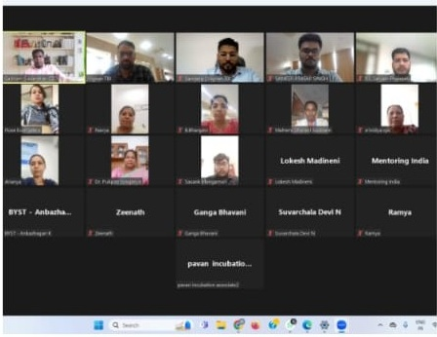
Google Meet Screenshot 2 – Online expert session and learning interaction
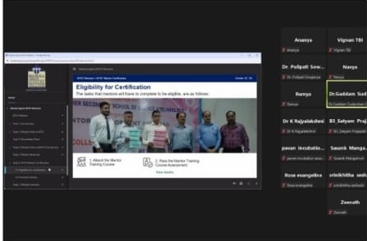

9. Model Certificate
Model certificate details (transcribed): Kakumanu Pavan Kumar successfully completed the Bharatiya Yuva Shakti Trust (BYST) Mentor Development Programme, BYST Online Learning Modules. The certificate records the award date as 18 October 2024. This is included as a model certificate for reference and does not establish that certificates were distributed to all 40 programme participants.
